**Market Analysis in Banking Domain**

* 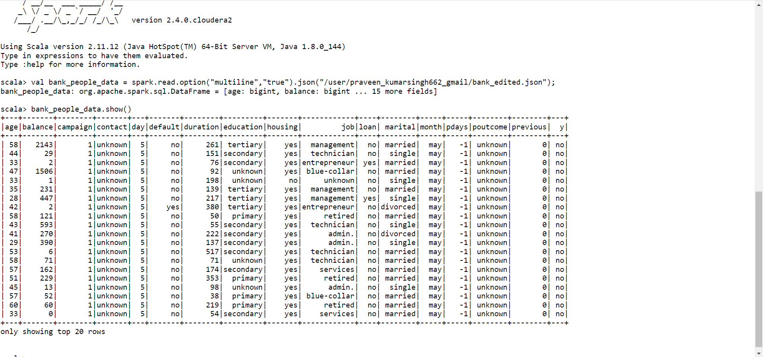bank_people_data.show()
* bank_people_data.select(max($"age")).show()
* bank_people_data.select(min($"age")).show()
* bank_people_data.select(avg($"age")).show()
* 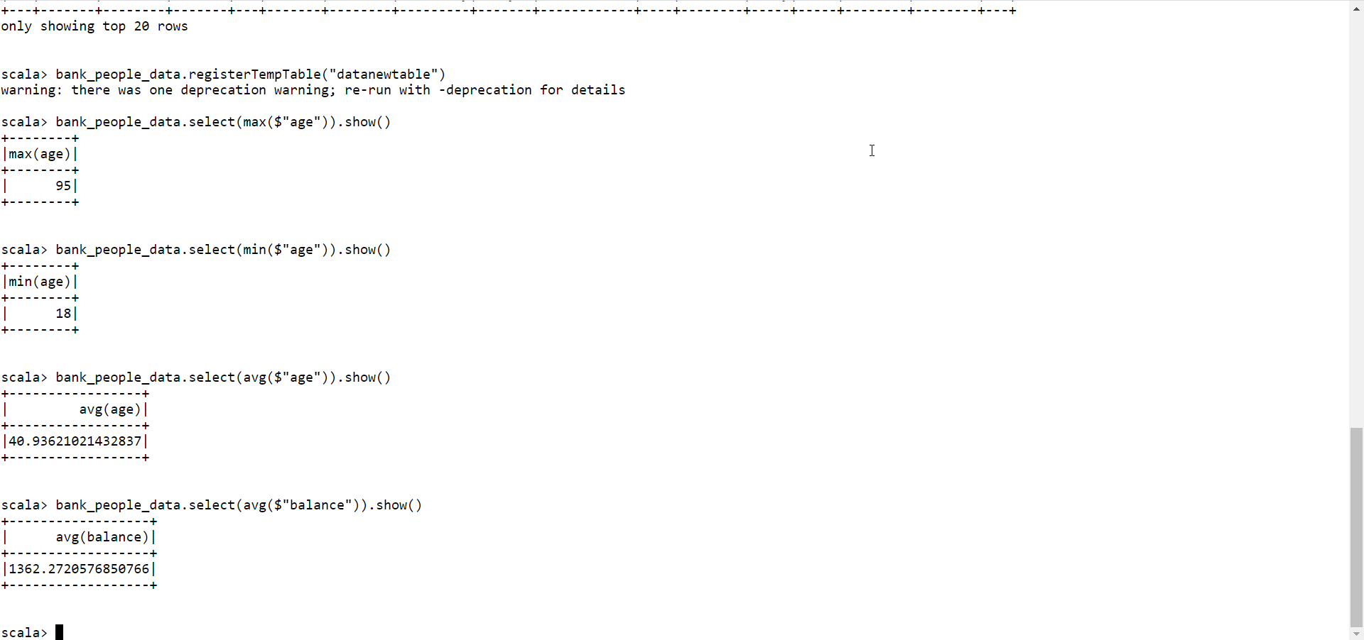bank_people_data.select(avg($"balance")).show()
* val median = spark.sql("SELECT percentile_approx(balance, 0.5) FROM datanewtable").show()
* 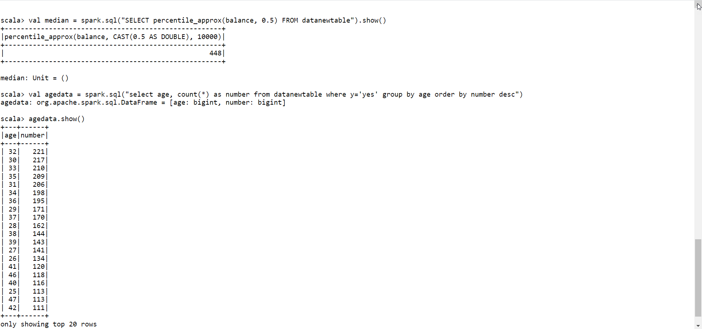agedata.show()
* maritaldata.show()
* 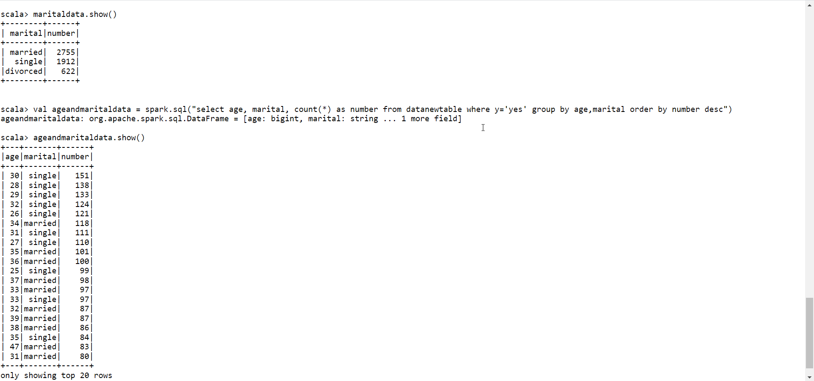ageandmaritaldata.show()
* 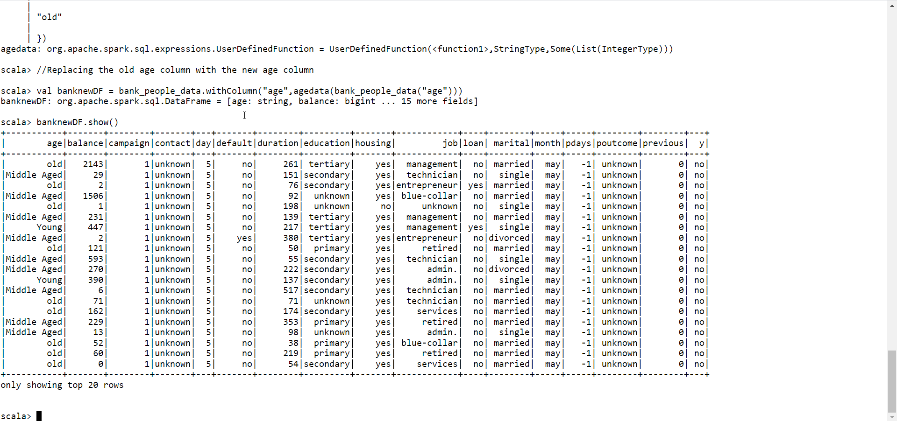banknewDF.show()
* 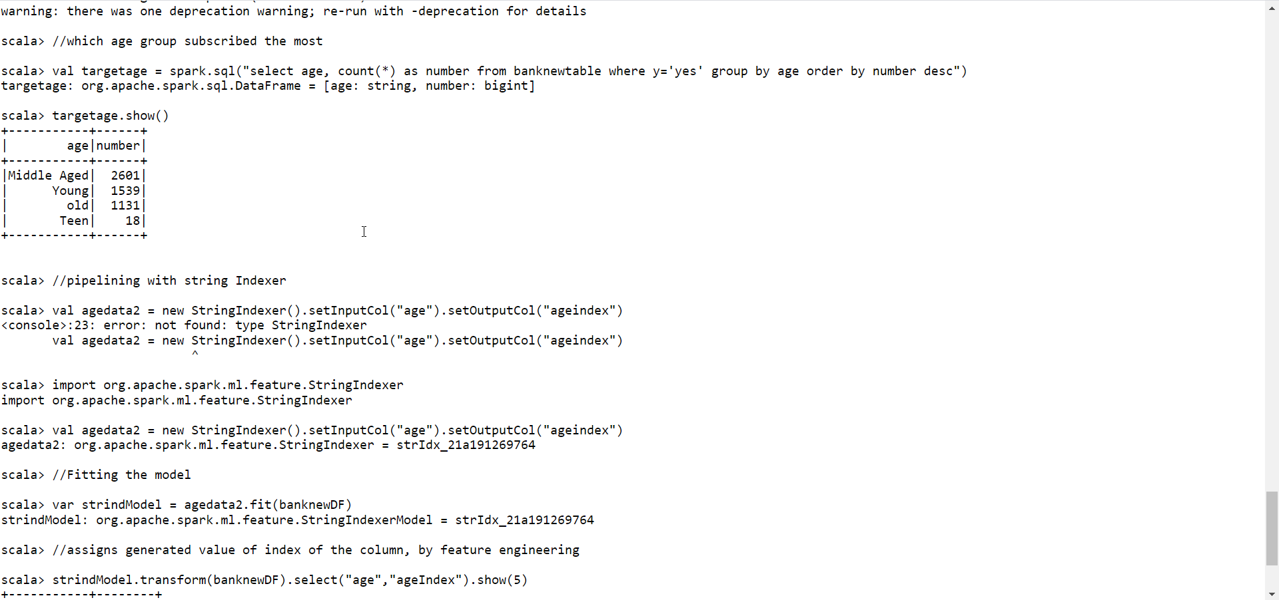targetage.show()
* 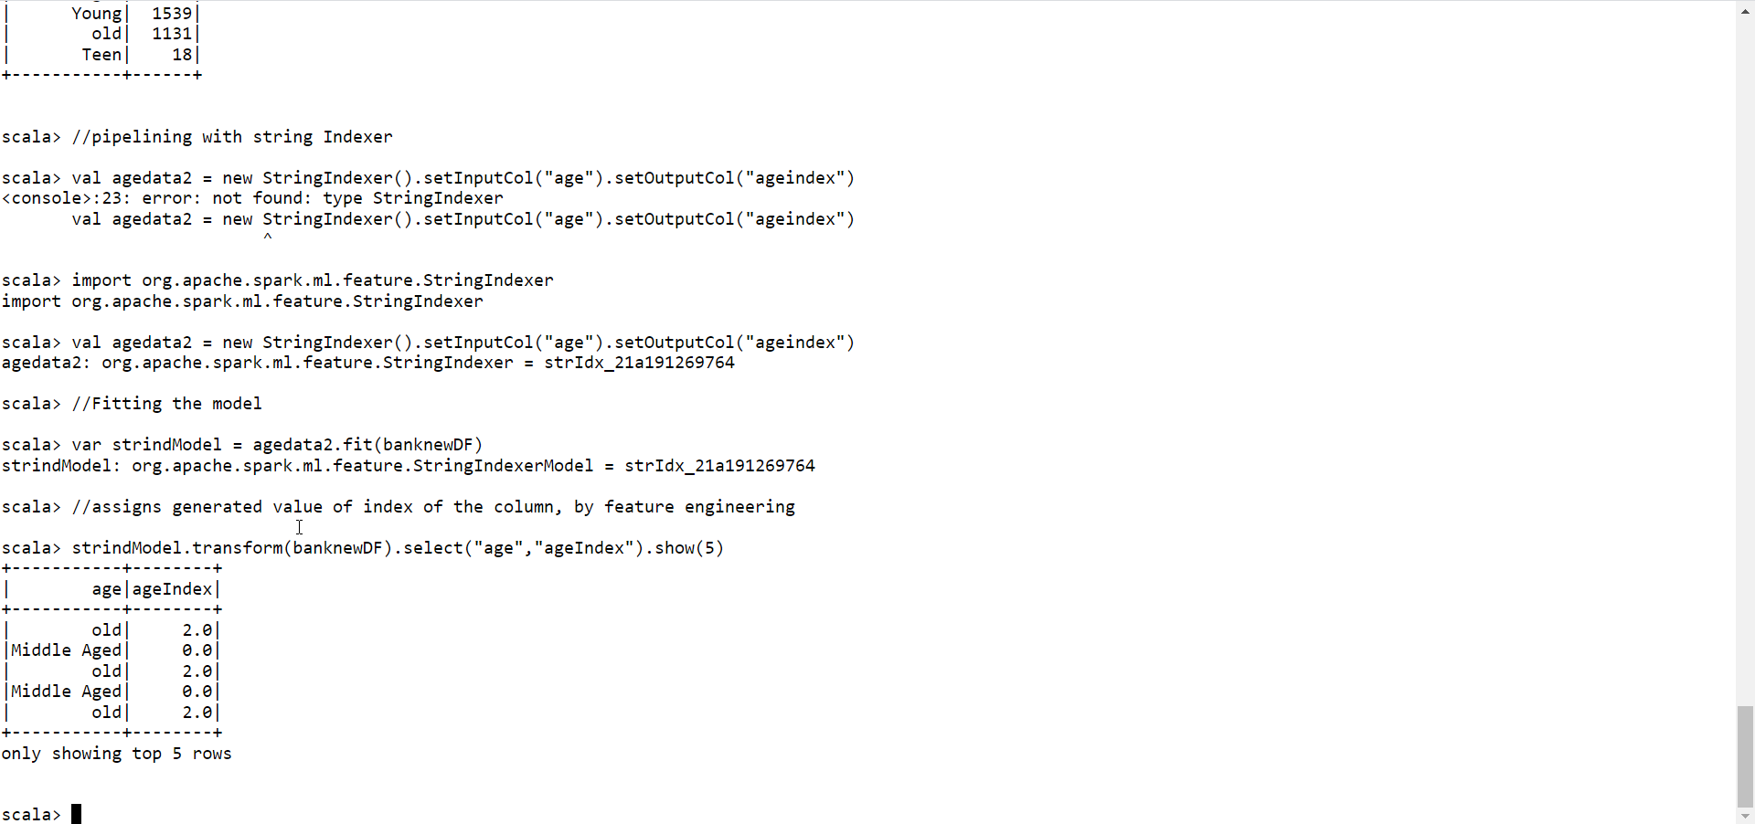strindModel.transform(banknewDF).select("age","ageIndex").show(5)